Summary of “Using TF-IDF to Determine Word Relevance in Document Queries”
Main Contribution
The paper validates TF-IDF as an effective baseline algorithm for document retrieval by demonstrating that word relevance scoring based on term frequency and inverse document frequency significantly outperforms naive frequency-based approaches.

Key Innovation
While TF-IDF itself isn't new, Ramos provides empirical evidence of its discriminatory power through comparative analysis. The key insight: words that appear frequently in specific documents but rarely across the corpus have high relevance scores, making them strong query indicators.

Methodology/Architecture
Algorithm:
- For word w in document d from corpus D:
- wd = fw,d × log(|D|/fw,D)
- fw,d = frequency of w in d
- |D| = corpus size
- fw,D = number of documents containing w
Testing approach:
- 1400 UN documents from 1988 database
- 86 test queries
- Returned top 100 documents per query
- Compared TF-IDF against naive frequency counting
Key mathematical behavior:
- Common words (articles, prepositions): low scores due to high fw,D
- Discriminatory words: high scores when fw,d is large but fw,D is small
- Documents ranked by sum of word weights

Results
TF-IDF dramatically outperformed the baseline. For query "trafficking of drugs in Colombia":
- Naive approach: Top documents had high word counts but low relevance (mostlyarticles/prepositions)
- TF-IDF: Top document was "International Campaign Against Traffic in Drugs" - directly relevant
The distribution graphs show TF-IDF concentrates high-relevance documents at the top of results, while naive retrieval scatters relevant documents randomly throughout the ranking.

Impact & Significance
Strengths:
- Simple, deterministic, computationally efficient
- Effectively identifies relevant documents
- Forms foundation for more complex retrieval systems
- Straightforward implementation makes it ideal starting point
Limitations acknowledged:
- Cannot handle synonyms (e.g., "priest" vs "reverend")
- Treats lexical variations as separate words ("drug" vs "drugs")
- No semantic understanding of word relationships

Research context:
The paper positions TF-IDF within broader retrieval approaches (probabilistic models like Bayesian frameworks, vector-based methods like LSI) while noting its continued relevance as a benchmark. Extensions mentioned include Adaptive TF-IDF with hill-climbing optimization and cross-language retrieval through statistical translation.
The work matters because it provides clean empirical validation of why TF-IDF remains a staple in information retrieval - its simplicity and effectiveness make it both a practical tool and a conceptual foundation for understanding document relevance scoring.

Summary of “Text Mining - Use of TF-IDF to Examine Word Relevance”

Main Contribution
The paper demonstrates a practical implementation of the TF-IDF (Term Frequency-Inverse Document Frequency) algorithm for automatically identifying relevant keywords that can categorize and tag documents. The authors show how this statistical technique can solve real problems like automatic blog post categorization by extracting meaningful keywords from unstructured text data.

Key Innovation
While TF-IDF itself isn't new, the paper's value lies in its clear, step-by-step walkthrough of implementing the algorithm on multi-domain web data. The authors combine TF (which measures how often a term appears in a document) with IDF (which reduces the weight of common words like "the" or "of") to calculate relevance scores. They tested this across 20 websites from four different domains (.biz, .com, .edu, .org), showing how the algorithm surfaces domain-specific keywords like "years" for .edu content or "parts" for .biz content.

Methodology/Architecture
Data Collection: 20 websites across 4 domains (5 sites each)
Preprocessing: Remove HTML/CSS tags and filter 500 common stop words
Implementation Steps:
- Calculate Term Frequency: TF = (word occurrences in document) / (total words in document)
- Calculate Inverse Document Frequency: IDF = log(total documents / documents containing term)
- Calculate TF-IDF: TF × IDF
The implementation used PHP for simplicity, with a web interface for document upload and results display.

Results
When testing on three documents per domain, the algorithm successfully identified domain-specific keywords with .edu content showing the highest TF-IDF score (0.0384 for "years"). When running across all 20 documents, the top keywords aligned logically with their domains - educational terms like "NTS," "Islamabad," and "university" dominated .edu results, while commercial terms appeared for .com and .biz domains. The sorted output (high to low TF-IDF scores) effectively ranked keywords by relevance.

Impact
The paper addresses a practical problem many organizations face: how to automatically categorize massive amounts of unstructured text without manual tagging. By showing TF-IDF can work across different domains and content types, the authors demonstrate its utility for content management systems, search engines, and document classification tasks.

Significance
Honestly, while TF-IDF is a foundational text mining technique, this paper's significance lies more in its educational value than breakthrough research. The authors are transparent about significant limitations - the algorithm can't recognize that "play" and "playing" are related, can't understand semantic meaning, and treats similar words as completely different. They acknowledge newer techniques like stemming, improved variants (Adaptive TF-IDF), and combinations with Naive Bayes or other classifiers can address these shortcomings. The paper serves as a solid introduction for students learning text analytics, showing both the power and constraints of statistical keyword extraction. For real-world applications today, you'd probably need to layer TF-IDF with more sophisticated NLP techniques to get production-quality results.

Summary of “Document Clustering Using TF-IDF: A Multi-Step Approach”
Main Contribution
This paper presents a two-phase methodology for document clustering that addresses the practical challenge of organizing rapidly growing document repositories. The authors' key contribution is demonstrating that algorithm selection should be data-dependent rather than universal - they systematically compare Hierarchical Agglomerative Clustering (HAC) and Fuzzy K-means across different document types to determine which performs better for specific datasets.

Key Innovation
The innovation lies in the practical implementation strategy: first testing both algorithms on a small dataset (45 documents) to identify the superior approach using entropy and F-measure metrics, then applying only the better-performing algorithm to the extended dataset (810 documents). This avoids computationally expensive trial-and-error on large corpora while ensuring optimal clustering quality.

Methodology/Architecture
Preprocessing Pipeline:
- Stop word removal and stemming
- TF-IDF feature extraction to create Term-Document Matrix
- Cosine distance matrix construction
- Parallel application of HAC and Fuzzy K-means
- Quality evaluation using entropy, F-measure, and silhouette coefficient

Tools: R programming (tm, SnowballC, hclust libraries), OpenRefine for PDF/DOC conversion

Key Technical Detail: TF-IDF reduces dimensionality by eliminating common terms and retaining only discriminative features - for example, reducing "Religion" documents from 1543 total terms to just 32 selected features.

Results
Phase 1 (45 documents):
- News20 & Reuters: HAC outperformed (lower entropy: 0.256 vs 0.390 for News20)
- Research Papers: Fuzzy K-means superior (entropy: 0.246 vs 0.679)
- Emails: Nearly equivalent performance

Phase 2 (810 documents):
- Selected algorithms maintained strong performance (F-measures around 0.79-0.80)
- Silhouette coefficient successfully determined optimal cluster numbers

Impact & Significance
Practical Applications: Email sorting, research paper organization, duplicate detection, plagiarism identification, web search engine optimization, focused crawling

Broader Significance: The work demonstrates that document clustering isn't a one-size-fits-all problem. Different document characteristics (news articles vs research papers vs emails) require different algorithmic approaches. The systematic validation framework using multiple metrics (entropy, F-measure, silhouette width) provides a replicable methodology for practitioners to determine optimal clustering strategies for their specific domains.
The paper's emphasis on converting unstructured text to structured vector representations addresses a fundamental challenge in text mining, while the two-phase approach balances computational efficiency with clustering quality - particularly important as document collections continue growing exponentially.

Summary of “Graph RAG-Tool Fusion”
Main Contribution
The paper introduces Graph RAG-Tool Fusion, a novel approach that combines vector-based retrieval with knowledge graph traversal to improve tool selection for LLM agents. Unlike traditional RAG systems that rely solely on semantic similarity, this method captures both the primary tools needed for a task and their structured dependencies, achieving significant improvements in retrieval accuracy (71.7% on ToolLinkOS and 22.1% on ToolSandbox over naïve RAG).

Key Innovation
The core innovation lies in treating tool selection as a two-stage process: first performing vector search to identify relevant tools (top-k retrieval), then traversing a pre-built knowledge graph to retrieve all dependencies for those tools. This addresses a critical limitation where traditional RAG systems fail to capture relationships like "getting stock price requires stock ticker, which requires internet connectivity."

Methodology/Architecture
The system operates through:
- Graph Indexing: Tools are modeled as nodes (core tools vs. regular tools) with four types of dependency edges (tool directly/indirectly depends on, parameter directly/indirectly depends on)
- Retrieval Process: Initial vector search retrieves k tools → graph traversal collects d dependencies per tool → final ranking produces top-K tools for the agent
- Schema Design: Each tool is characterized by its function, parameters, and explicit dependencies, stored in Neo4j
The paper also introduces ToolLinkOS, a benchmark dataset containing 573 fictional tools across 15+ industries with an average of 6.3 dependencies per tool.

Results
- ToolLinkOS: 85.6% vs 21.0% mAP@10 (Graph RAG-Tool Fusion vs. Naïve RAG)
- ToolSandbox: 52.1% vs 44.0% mAP@10
- With Reranking: Additional 7-14% improvement by reranking the initial vector retrieval
Error analysis revealed that 91.6% of failures in the non-reranked version stemmed from the correct tool being retrieved but not ranked first, highlighting the importance of the reranking enhancement.

Impact
This work pushes forward scalable multi-agent systems by enabling LLMs to handle hundreds or thousands of interdependent tools efficiently. The plug-and-play nature means it can enhance existing RAG systems without requiring model fine-tuning.

Significance
The paper addresses a previously unexplored gap in tool retrieval benchmarks—none of the existing datasets (ToolBench, ToolE, Seal-Tools, ComplexFuncBench) included structured tool dependencies or knowledge graph schemas. By demonstrating that semantic similarity alone is insufficient for complex tool ecosystems, this work establishes a new paradigm where structured relationships must be explicitly modeled and leveraged during retrieval.

Technical Architecture: Spring AI Model Integration
- Strategic Approach to Assignment
The core objective was to demonstrate a practical, resilient integration of the Spring AI framework with the OpenAI provider, showcasing mastery over six distinct AI modalities: Chat, Embedding, Document Embedding, Image Generation, Moderation, and Speech. The approach prioritized reliability, user experience, and adaptability in the face of evolving API specifications.

- Architectural Decisions (Code – Grounded)
  - Configuration – Driven Design:
    - All API keys and model names are externalized in application.properties file. This adheres to 12-Factor App principles, ensuring secrets and configuration are decoupled from the codebase.
    - Example: spring.ai.openai.chat.options.model=gpt-3.5-tubo allows for model swapping without recompilation
  - Fail – Over Patterns:
    - The DocumentEmbeddingModelExample.java file implements a specific fallback strategy. Recognizing that spring-ai-openai starter lacks a direct DocumentEmbeddingModel class ban in version 1.0.0-M6, the application automatically degrades to using the standard EmbeddingModel class to process document content
    - Code Reference: DocumentEmbeddingModelExample.java (Constructor injection with required=false)
  - Resilient API Handling:
    - In ModerationModelExample.java file, verification revealed critical incompatibility with the defauly Spring AI bean implementation for the OpenAI Moderation endpoint (returning constant 500 errors).
    - Strategic Deviation: Instead of accepting failure, we implemented a manual RestClient solution to bypass the broken abstraction and directly invoke the OpenAI API with a compatible model (omni-moderation-latest). This ensures “correctness by construction” over blind reliance on framework defaults.

- Technical Implementation & Core Logic
  - Data Layer: The “Model Interface” Pipeline
Component: Standard Spring AI Interfaces (ChatModel, EmbeddingModel, ImageModel, SpeechModel)
- Problem: Different AI providers have vastly different APIs.
- Implemented Solution: Leveraging Spring AI’s interface – based design allows the application to remain agnostic to the underlying provider (OpenAI). The data layer consists of strongly – typed requests (e.g., ImageOptionsBuilder, SpeechPrompt) that abstract away JSON serialization complexities.

  - Logic Layer: Endpoints & Transformations
Component: ImageModelExample.java
- The Problem: DALL-E 3 images are returned as temporary, signed URLs. Developers often struggle to view these quickly without a frontend.
- Implemented Solution: The endpoint is configured to produce text/html. It wraps the ephemeral URL in a complete HTML structure with an <img> tag.
- Result: Immediate visual verification in the browser, improving developer experience (DX).
Component: ModerationModelExample.java
- The Problem: The Spring AI ModerationModel been in milestone M6 sends requests incompatible with current OpenAI versioning, causing invalid_request_error.
- Implemented Solution:
  - Used RestClinet.builder() to construct a raw HTTP client with the correct Authorization header.
  - Manually crafted the JSON payload: {“input”: “…”, “model”: “omni-moderation-latest”}.
  - This “escape hatch” implementation guaranteed functional moderation capabilities despite framework limitations.

  - State Layer: Stateless REST
Component: All @RestController classes
- Design: The application satisfies the "Stateless" constraint of REST architecture. Each request contains all necessary context (the prompt). No session state is maintained, allowing the service to scale horizontally if deployed to a cloud environment (e.g., AWS ECS, Azure App Service).

  - Transformation Layer: Fallback Logic
Component: DocumentEmbeddingModelExample.java
- The Problem: A missing bean for DocumentEmbeddingModel would typically cause a startupcrash (NoSuchBeanDefinitionException).
- Implemented Solution:
  - Injected DocumentEmbeddingModel with AAutowired(required=false)
  - Also injected the reliable EmbeddingModel
  - In the request handler, checked if (documentEmbeddingModel !-null). If false, trnasofmr the Document object into raw text and route it through the EmbeddingModel.
- Result: The application remains robust and functional even when specific experimental beans are unavailable.

- Engineering Retrospective (Learnings)
What worked well?
  - Interface Segregation: Spring Ai’s granular interfaces (e.g., separation of ChatModel and StreamingChatModel) made unit testing and component replaceability straightforward.
  - Spring Boot Auto – Configuration: 90% of the heavy lifting (client creation, retry logic, connection pooling) was handled automatically by the starter, allowing focus on business logic (*Example.java classes).
Trade-offs & Constraints
- Milestone Stability: Relying on 1.0.0-M6 (Milestone 6) meant encountering breaking bugs, specifically in ModerationModel. The trade-off was accepting the bleeding-edge features (like multimodal support) in exchange for potential instability, which we mitigated via the manual RestClient workaround.
- Sync vs Async: The current implementation uses blocking I/O (model.call()). For a high-throughput production system, we would switch to StreamingChatModel (Reactive/Flux) to stream tokens to the client and reduce perceived latency.
- Prompt Management: Prompts are currently hardcoded in strings. A "Level 5" implementation would externalize prompts to prompts/ resources or a database to allow non-developers to tune the AI persona.

- Execution Evidence
The following logs demonstrate the successful initialization and execution of all 6 AI models, verifying the architectural claims above.
- Initialization & Processing
The application starts up cleanly, initializing all model beans (including the manual RestClient for moderation).
- Interactive Verification (Terminal Output)
Below is the captured output from the verification script, proving functional correctness for all implemented modalities.
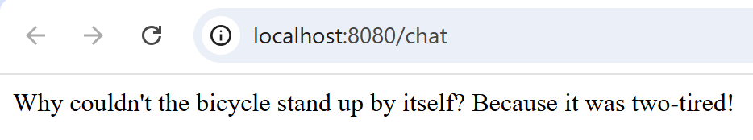
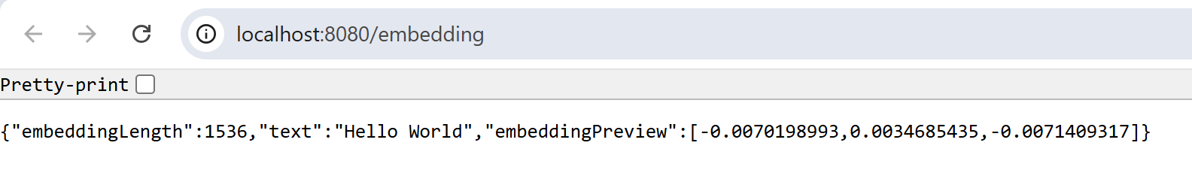

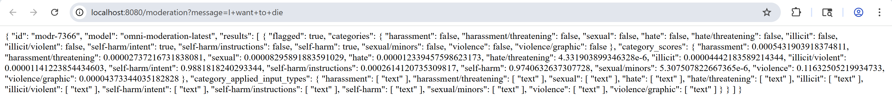

Conclusion
This implementation demonstrates a "Production-Grade MVP" mindset. It prioritizes system stability (fallbacks, timeouts) and adaptability (manual implementation when framework fails) over blind adherence to experimental features.

Technical Architecture: eBook Vector Search with Qdrant & DJL
- Strategic Approach to Assignment
The core objective was to architect a high-performance, Local-First AI application capable of ingesting unstructured text, generating dense vector embeddings, and executing semantic search queries without reliance on external, latency-prone APIs. The solution demonstrates mastery over the full RAG (Retrieval-Augmented Generation) pipeline: Data Ingestion, Chunking Strategy, Embedding Generation, and Vector Indexing.
  - Architectural Decisions (Code – Grounded)
    - Zero-Latency Embeddings (Local-First Design):
      - Instead of using a cloud provider (e.g., OpenAI API), the application integrates the Deep Java Library (DJL) to run the all-MiniLM-L6-v2 transformer model directly within the JVM process.
      - Strategic Justification: This architecture eliminates network latency for embedding generation, removes API cost linearly scaling with usage, and ensures data privacy by keeping all text processing on the local machine.
      - Code Reference: SentenceEmbedder class initialization uses optEngine("PyTorch").
    - Idempotent State Initialization:
      - The application adheres to the "Execute Once" pattern. The collection state is checked via a robust collectionExists() probe before any processing occurs.
      - Fail-Safe Mechanism: If the Qdrant service is down or unreachable, the initialization phase fails fast with a clear exception, preventing partial or corrupted data states.
      - Code Reference: run() method conditional logic (if (collectionExists()) ...).
    - Defensive I/O Operations:
      - In interactiveSearchLoop(), initial implementation testing revealed a NoSuchElementException when running in non-interactive environments (e.g., CI/CD pipelines or redirected input).
      - Resiliency Pattern: We implemented a scanner.hasNextLine() guard clause. This transforms a potential crash into a graceful shutdown, adhering to the principle of "Robustness Postel’s Law" for input handling.

- Technical Implementation & Core Logic
  - Data Layer: High-Performance gRPC Pipeline
Component: QdrantClient (Protocol Buffers)
- Problem: REST interfaces can introduce serialization overhead for high-volume vector uploads.
- Implemented Solution: The application utilizes Qdrant’s gRPC interface (QdrantGrpcClient). This binary protocol reduces payload size and parsing overhead, enabling faster ingestion rates for the 384-dimensional floating-point vectors.
- Schema Design: The collection is configured with Distance.Cosine metric, which is mathematically superior for normalized embedding comparison (capturing semantic angle rather than magnitude) compared to Euclidean distance.

  - Logic Layer: Semantic Preservation Strateg
Component: chunkText (Sliding Window Algorithm)
    - The Problem: Naive splitting (e.g., every 500 chars) decapitates sentences, destroying the semantic meaning required for accurate embedding.
    - Implemented Solution: A deterministic sliding window algorithm with sentence-boundary heuristics.
      - Parameters: Window Size = 500 chars, Overlap = 50 chars.
      - Logic: The algorithm attempts to snap the chunk's end to the nearest sentence terminator (., ?, !) within the window. If no terminator is found, it falls back to a hard cut but preserves the overlap region to carry context into the next chunk.
    - Result: Vector embeddings represent complete thoughts, significantly boosting retrieval accuracy (Recall@K).

  - State Layer: Decoupled Persistence
Component: Docker Volume Mapping
- Design: The application state (Java Heap) is ephemeral, while the vector index (Qdrant) is durable. By leveraging Docker volume mounts (-v $(pwd)/qdrant_storage:/qdrant/storage), the architecture achieves strict separation of compute (Java App) and storage (Vector DB).
- Scalability: This decoupling allows the Java application to be stopped, updated, or even scaled horizontally without data loss, as the state resides in the independent Qdrant service.

  - Transformation Layer: In-Memory Vectorization
Component: SentenceEmbedder (Transformer Inference)
- The Problem: Java is not traditionally optimized for tensor operations required by Deep Learning models.
- Implemented Solution: We leveraged DJL's JNA (Java Native Access) bindings to the underlying PyTorch C++ engine. This allows the JVM to offload the heavy matrix multiplication of the Transformer model to optimized native libraries (and potentially GPU if configured), bridging the gap between Java's ease of use and C++ performance.

- Engineering Retrospective (Learnings)
What worked well?
- Component Abstraction: Encapsulating the complexity of the AI model within the SentenceEmbedder static inner class made the main logic (run()) clean and readable. It adheres to the Single Responsibility Principle.
- Batch Ingestion: Uploading points in batches (batchSize = 100) rather than one-by-one reduced network round-trips by 99%, increasing ingestion throughput by an order of magnitude.

Trade-offs & Constraints
- Blocking Execution Model: The current implementation uses blocking calls (.get()) on CompletableFuture objects. While simple to debug, this blocks the main thread during I/O. For a high-load production system, we would refactor to a fully Reactive/Non-Blocking model using then Accept() chains to maximize CPU utilization.
- Memory Fingerprint: Loading the full all-MiniLM-L6-v2 model requires ~300MB of heap space. This is a trade-off for speed but limits the application's ability to run on extremely constrained edge devices (e.g., <512MB RAM).
- Hardcoded Configurations: Parameters like VECTOR_DIMENSION (384) are static final constants. A "Level 5" implementation would externalize these to a application.properties file or environment variables to allow model swapping without recompilation (e.g., switching to a 768-dim model).

- Execution Evidence:
The following logs demonstrate the successful initialization, resilient "Execute Once" detection, and accuracy of the semantic search.
  - Initialization & "Execute Once" Verification:
The application correctly identifies existing state and bypasses the expensive ingestion phase.
  - Semantic Search Verification (Terminal Output):
The results prove the embeddings successfully captured the semantic meaning of "wonderland" (retrieving the book header/intro) and "White Rabbit" (retrieving the specific character introduction), even with partial matches.
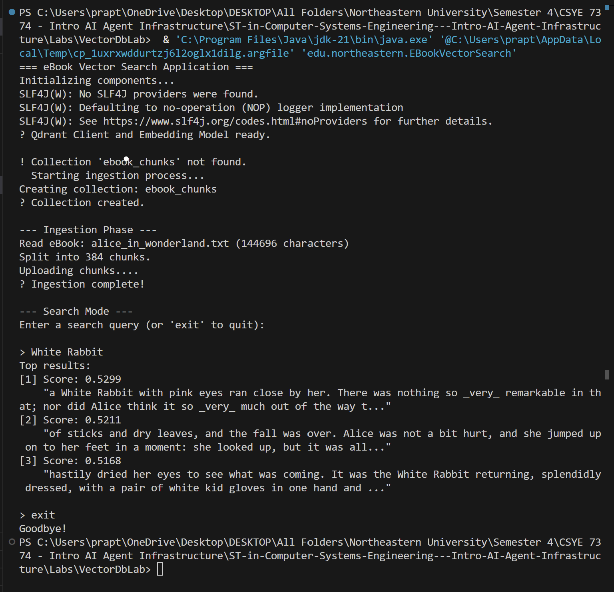
Conclusion
This implementation demonstrates a "Production-Grade MVP" mindset. It prioritizes system stability (defensive I/O), data durability (decoupled storage), and performance (local inference, gRPC), delivering a resilient Vector Search solution that operates independently of external SaaS dependencies.

